Question 1:
https://www.hackerrank.com/challenges/for-loop-in-c/problem
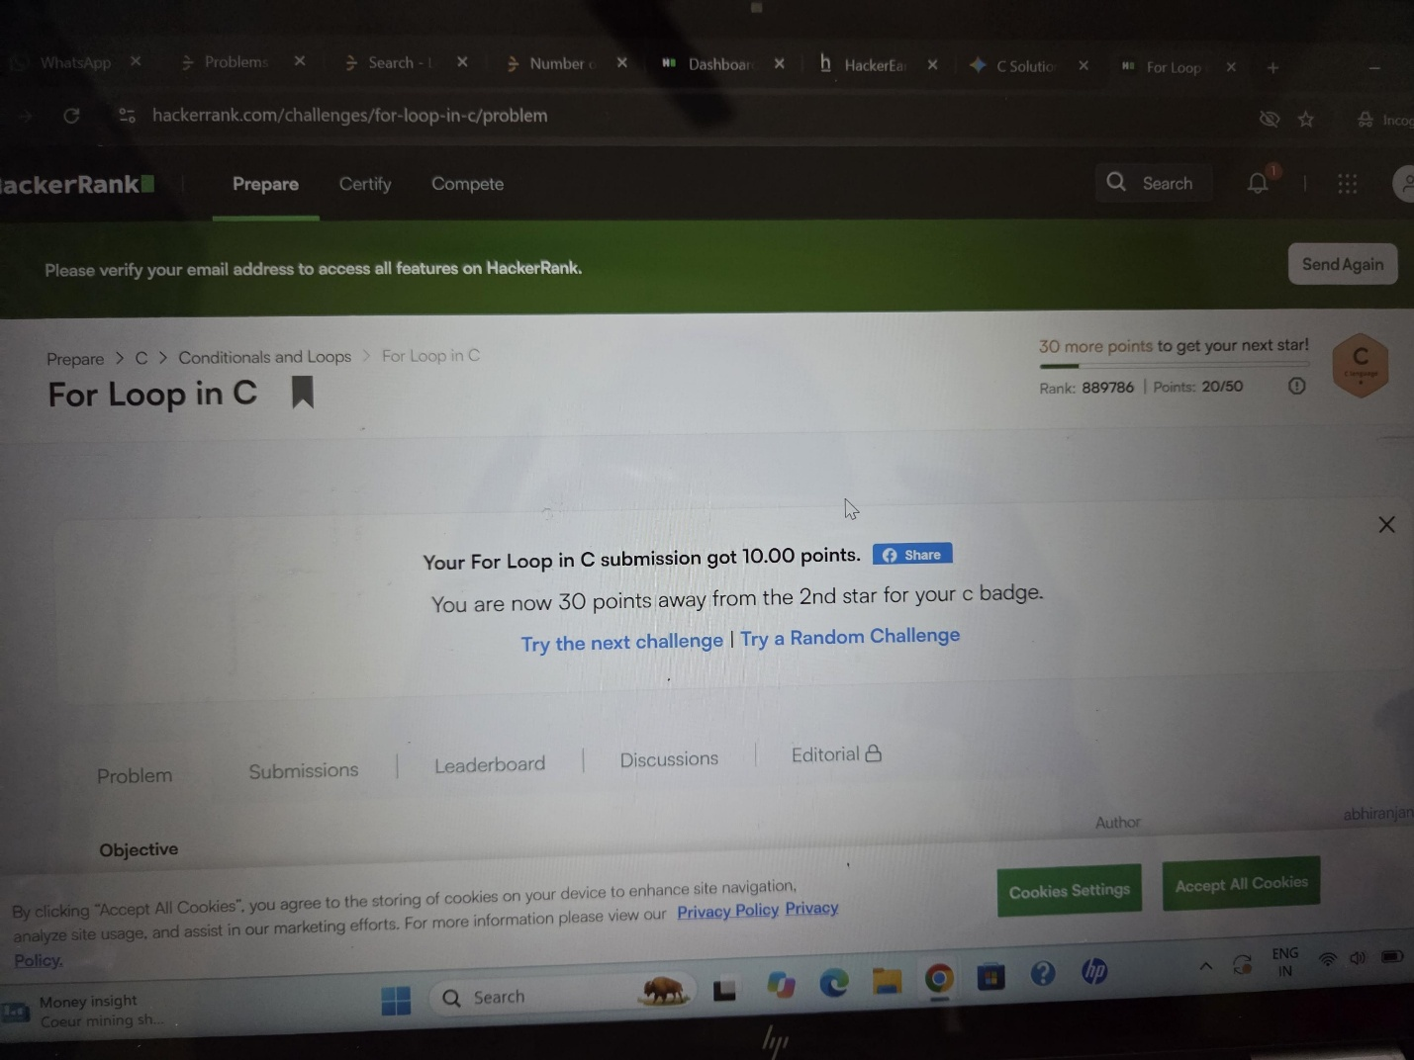

Question 2:
https://leetcode.com/problems/number-of-steps-to-reduce-a-number-to-zero/submissions/2191406602/
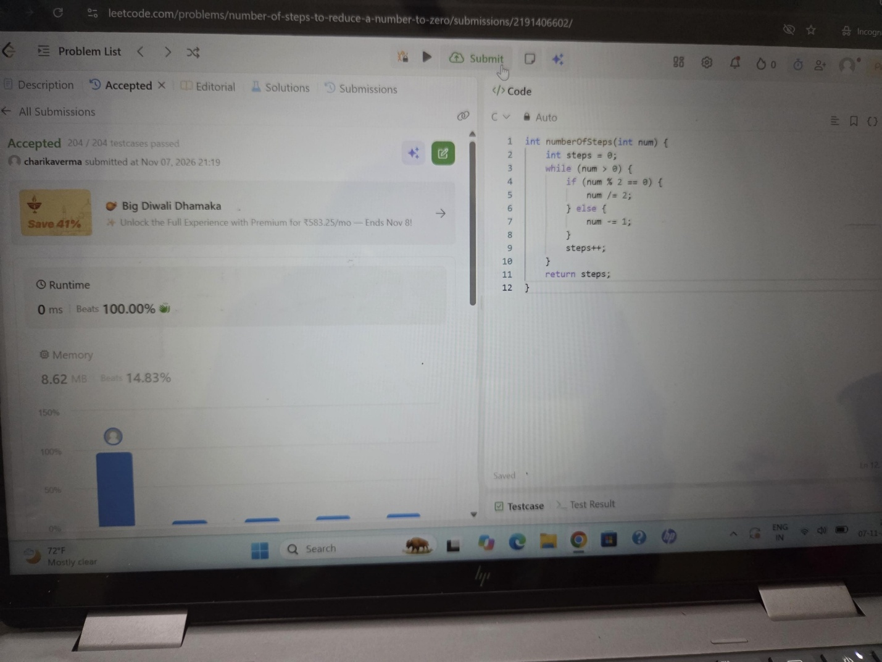

Question 3:
https://leetcode.com/problems/count-operations-to-obtain-zero/submissions/2191407370/
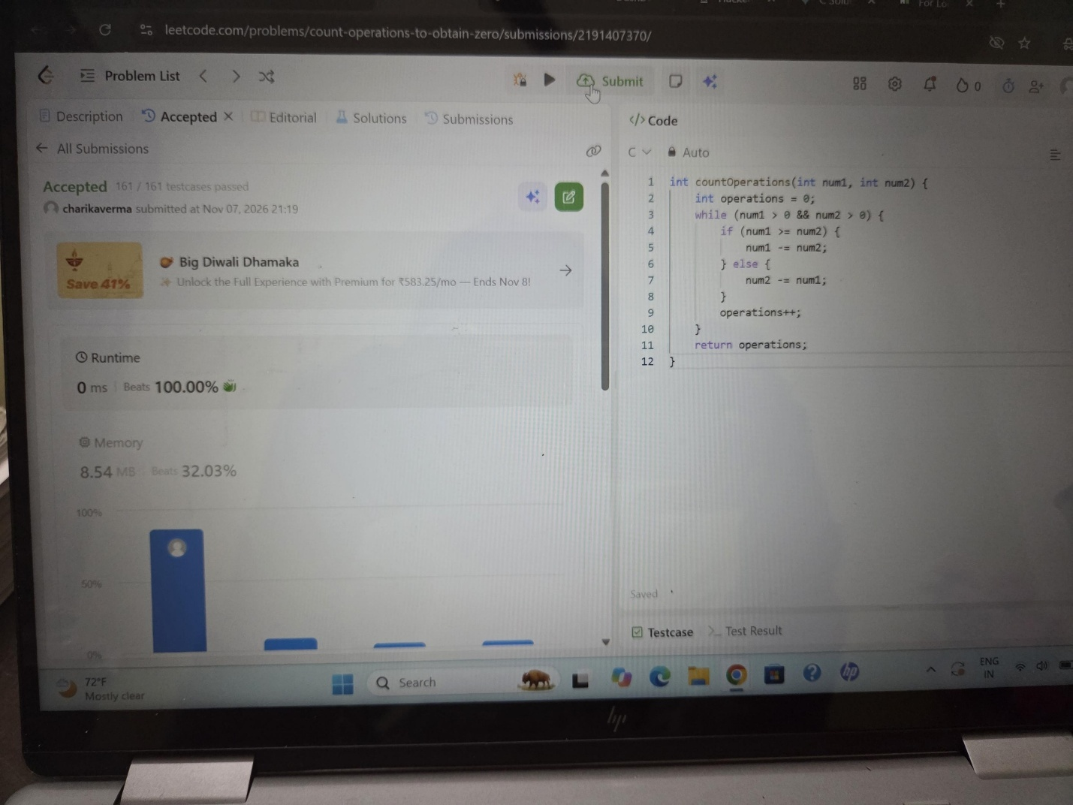

Question 4:
https://leetcode.com/problems/count-odd-numbers-in-an-interval-range/submissions/2191408970/


Question 5
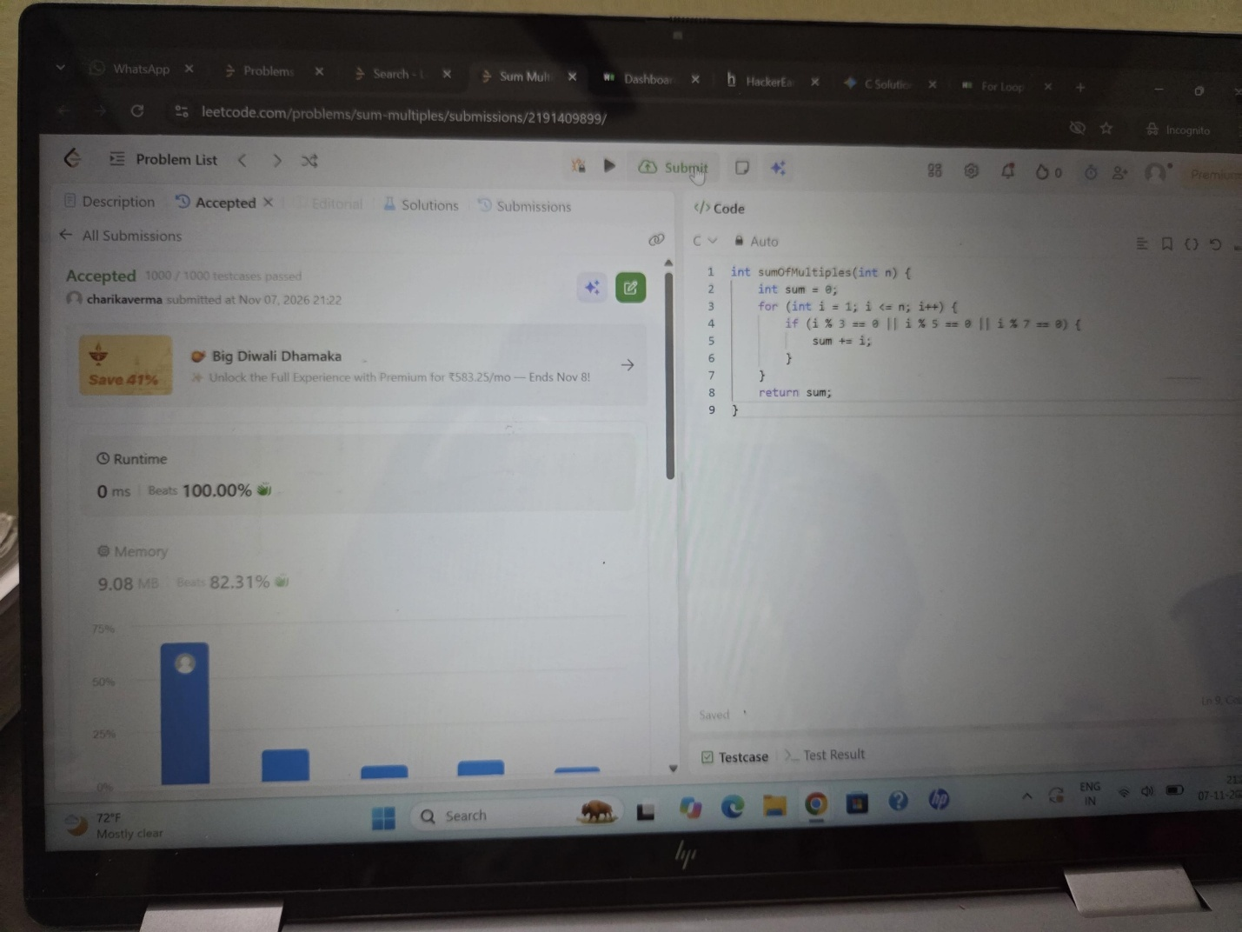
https://leetcode.com/problems/sum-multiples/submissions/2191409899/

Question 6:
https://www.hackerrank.com/challenges/kangaroo/problem


